Pump frequency conversion transformation plan
First, the control terminal wiring diagram
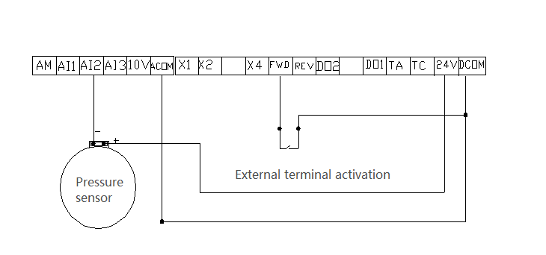
Tip: After connecting the line according to the wiring diagram, power on monitor U0-10 to see if the sensor signal is connected. The internal parameters show 0.00, AI2 and 24V are interchanged to the U0-10 monitoring sensor with signals (other numbers can be used for the next step).
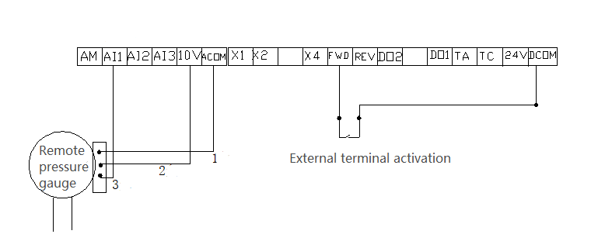
Tip: After connecting the line according to the wiring diagram, check whether the U0-09 pressure gauge signal is connected correctly. The U0-09 monitor has a signal (other numbers can be used for the next step).
Second, the basic PID operation parameters are set as follows:
P0-02=0 Select keyboard control; P0-02=1 select terminal operation.
P0-03= 8 Select the output frequency is determined by PID
P0-17=20 acceleration time, P0-18=20 deceleration time
PA-00= 0 Set pressure by PA-01
PA-01= 0~100% pressure setting
PA-02= 1 Select AI2 feedback source (sensor)
PA-02= 0 Select AI1 feedback source (pressure gauge)
PA-04= Range 10 kg set 100, 16 kg set 160, 0-100% for real-time monitoring
PA-05= 100 Proportional gain Setting range 0~100%
PA-08= 0 Hz PID reverse cutoff frequency
P7-03=8019, P7-04=0001 Set the operation time, monitor the running frequency, output voltage, output current, set pressure, feedback pressure
When P7-05=0803 is set to stop, monitor the set frequency, bus voltage, and set pressure.
Fourth, the operating instructions:
PA-01=pressure setting is 0-100%
Setting example: Generally we use a 16 kg sensor (pressure gauge), then PA-04=160. Connect the line as shown. When the pipe network requires 6.5 kg of pressure, set PA-01=41 (that is, 6.5 kg divided by 16 kg = 41%). The actual and feedback pressure can be monitored on the keyboard by the shift button (>>).
1, connect the sensor on-site constant voltage parameter adjustment (parameter adjustment is subject to the actual field, according to the following two phenomena, first coarse adjustment, then fine-tuning)
a. The actual pressure does not reach the set pressure and begins to frequency down. The solution is to adjust the P4-18 a little.
B.. The actual pressure has reached the set pressure and has not been down-clocked. The solution is to reduce the P4-20 by a little.
2, connected to the remote pressure gauge on-site constant pressure parameter adjustment (parameter adjustment is subject to the actual field, according to the following two phenomena first coarse adjustment, then fine-tuning)
1. The actual pressure does not reach the set pressure and starts to reduce frequency. The solution is to increase the P4-13 a little.
2. The actual pressure has reached the set pressure and has not been down-clocked. The solution is to reduce the P4-15 a little.
Five, sleep function
P8-49=45 wake-up frequency, as needed, P8-50=2 wake-up delay time, as needed
P8-51=38 Sleep frequency, as needed, P8-52=10 sleep delay time, as needed
PA-28=1, the operation is started when the machine is stopped, and the sleep function is not required.

